
VPS Healthcare announces $1m budget for R&D
Thursday, September 04 - 2014 @ 13:46
Integrated medical services provider VPS Healthcare has announced that is has allocated $1m for research and development in several key areas of medicine and treatment, focusing on chronic diseases and illnesses associated with old age.

VPS Healthcare – an innovative healthcare provider that is expanding its network of hospitals and clinics across the UAE – has outlined a plan for its Research Centre of Excellence, a state-of-the-art R&D practice dedicated to expanding our knowledge of chronic diseases and to provide innovative treatment solutions to help the medical community combat a variety of illnesses. “The first comprehensive project the Centre will undertake will be the study of Vitamin D-related ailments,” explained Dr. Shamsheer Vayalil, VPS Healthcare’s Managing Director

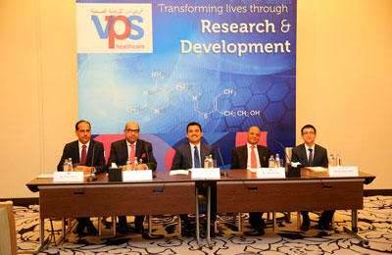

To lead R & D, VPS Healthcare has appointed Dr. Afrozul Haq, a renowned expert in the field of Vitamin D research, to act as the Principle Scientist. Dr. Haq, who pioneered Vitamin D research in the UAE in 2006 at SKMC, will work to establish a solid R&D platform within the rapidly expanding VPS Healthcare infrastructure. This is something Dr. Haq views as essential to the future of preventative medicine.

“Medical services cannot evolve without a commitment to research and development,” Dr. Shamsheer explained. “We all know that innovation is a key driver of sustained healthcare improvement, and that no new technologies or medications have ever been introduced without breakthroughs brought from purposeful research.” He cited as examples many treatments that are considered common today, such as insulin for diabetes and pervasive anti-cholesterol drugs – medical achievements that were unthinkable 50 years ago, but that quickly became a reality due to significant investments in expeditionary medical research.

The Research Centre of Excellence will work closely with a variety of partners in the UAE in the pursuit of medical innovation. The Centre will be able to leverage the research abilities of entities such as the burgeoning Khalifa University, Zayed University and Sheikh Khalifa Medical City, as well as VPS Healthcare’s many international partners.The Research Centre’s initial focus on Vitamin D will address key issues such as the causes and consequences of deficiencies, and the effect deficiency has on pregnancy within the UAE.

“Our research will explore the link between bone health in children, maternal Vitamin D concentrations and diseases of the newborn,” said Dr. Haq. “Also impact of Vitamin D deficiency on chronic kidney disease patients requiring dialysis.”

The Research Centre’s goal is to improve human life, beginning with the basics. The findings of its upcoming research will facilitate the creation of new protocols in the supplementation and fortification, guidelines, as well as provide insights into the retrospective and interventional aspects of Vitamin D. Research will be extended to cancer, diabetes and neurological disorders. This work will be conducted with some of the most advanced technology available for research.

